**Patent Draft**

**for**

**SMART HEALTH**

**Website**

**Prepared by**

**KHUSHI (2100290129005)**

[**mailto:khushi.2024cs1208@kiet.edu**](mailto:khushi.2024cs1208@kiet.edu)

**CHHAYANK TYAGI (2000290120059)**

[**mailto:chhayank.2024cs1010@kiet.edu**](mailto:chhayank.2024cs1010@kiet.edu)

**HANU AGARWAL (2000290120067)**

[**mailto:hanu.2024cs1020@kiet.edu**](mailto:hanu.2024cs1020@kiet.edu)

**KIET Group of Institutions**

**18th May, 2023**

**PROPOSED TITLE**

**SMART HEALTH**

**FIELD OF INVENTION**

* Healthcare Technology/Smart Health
* Combines technology and digital tools to improve storage of reports of patients
* Proposed system will provide one stop solution for selecting doctors according to the disease , Path-labs, Blood bank system and e-pharmacy.
* Aims to enhance the features of existing healthcare services by providing generic medicines at low cost.

**BACKGROUND**

* **Easy to select doctor**: Smart Health will ease the process of selecting doctor according to diseases a patients have from the list of doctors according to their availability and choices.
* **Cost-effective**: Smart Health is cost-effective compared to other healthcare applications, as they just have to create an account and registered themselves as patient or doctor.
* **Improved Storage of patient’ records**: This application can improve storage of patient records and will help in better diagnosis at next doctor and no need to carry or store traditionally
* **Generic Medicines**: It’ll help in searching same medicines at low cost on the basis of salt that medicines have and this feature is called generic medicine.

**OBJECTIVE**

* The main objective of SMART HEALTH is to accurately store the reports and records of patients such as lifestyle habits, and medical history.
* This project includes a website which will help in selecting the doctors for the particular disease based on the given symptoms by the user and his/her reports.
* The main motive of the proposed system is to provide one stop solution for many facilities and enhance existing health care systems by giving the feature of generic medicines.
* Our website helps in buying medicine at low cost by comparing cost of medicine on all the online pharmacy and it will help a lot to the patients.
* Doctors can easily view their all the patients either present or past.
* Doctors are also free to take help from the prescription of others doctors.

**DIAGRAMS**

**UseCase**

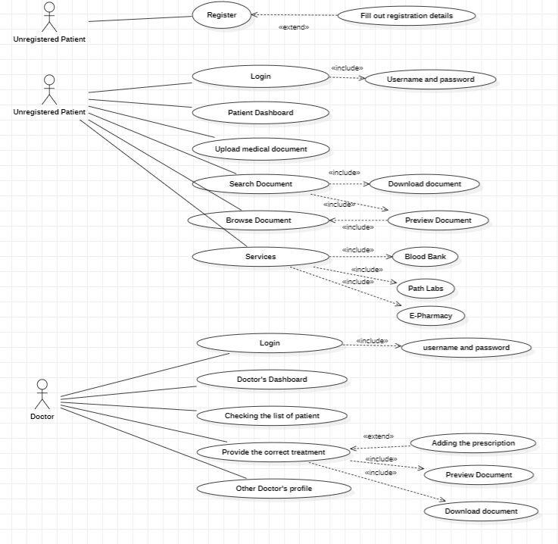

**Flowchart**

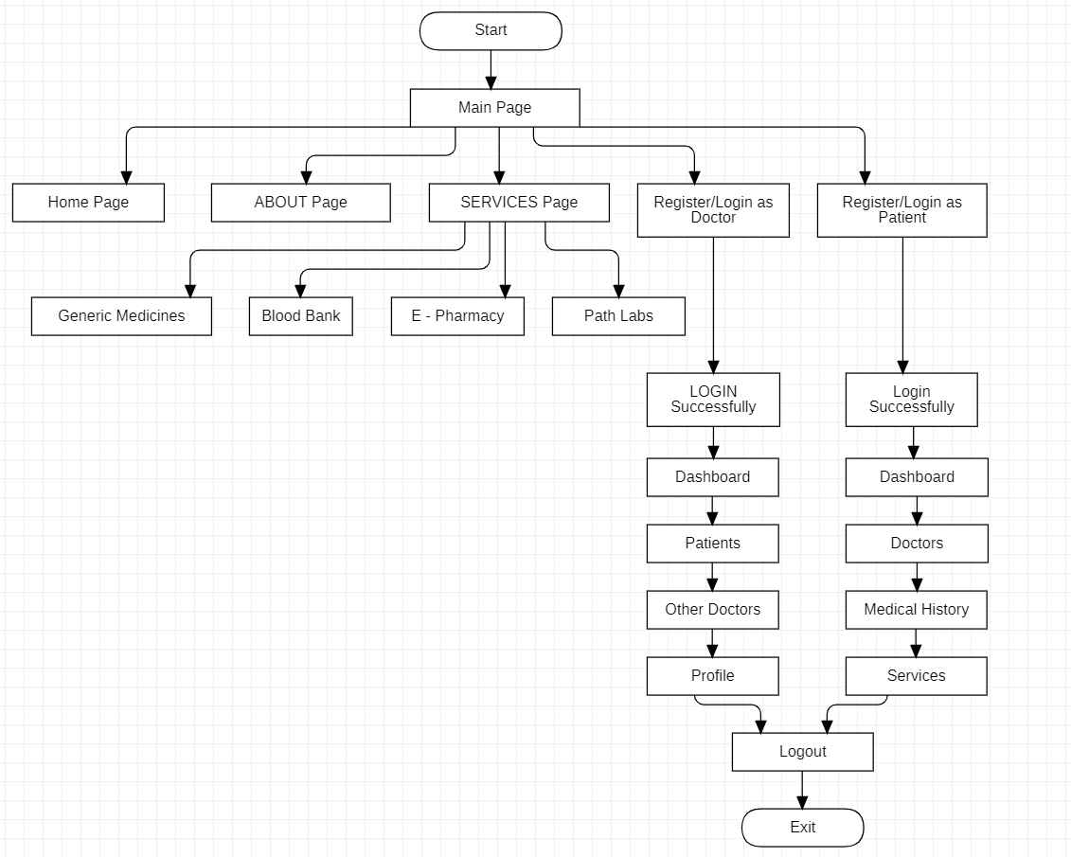

**DFD Level 0**

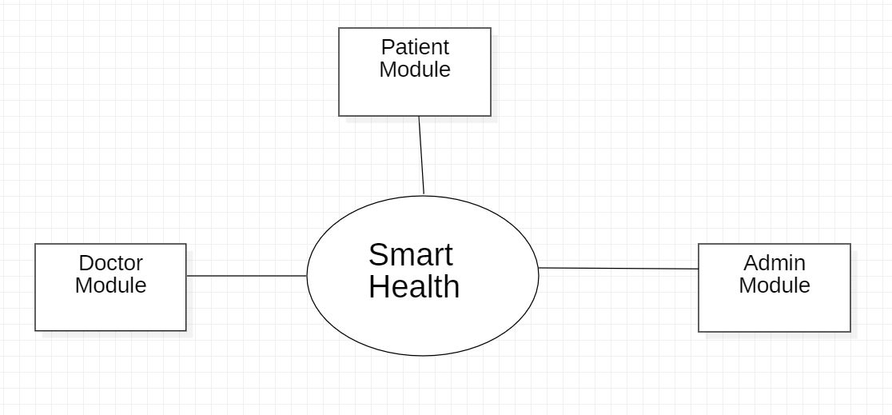

**DFD Level 1**

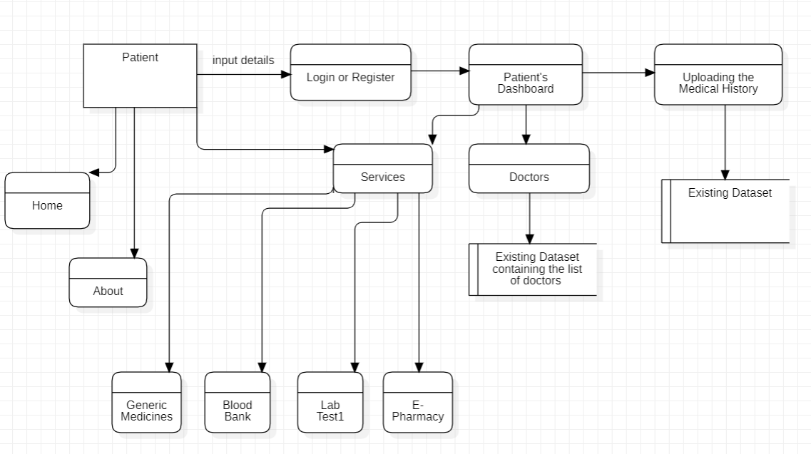

**Figure : Showing the patient’s data flow diagram level 1**

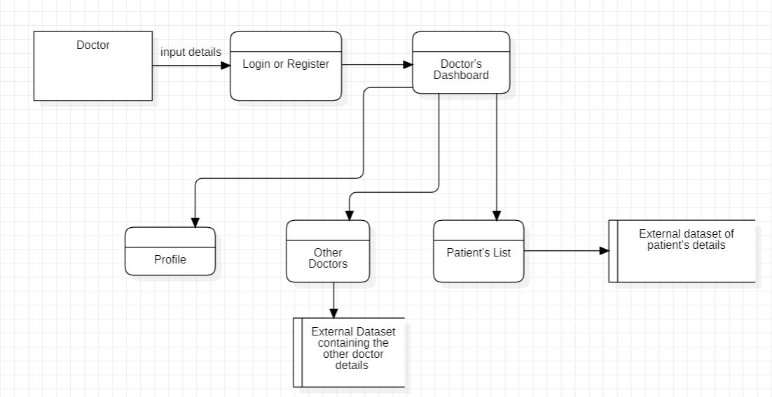

**Figure : Showing the Doctor’s dataflow diagram level 1**

**DFD Level 2**

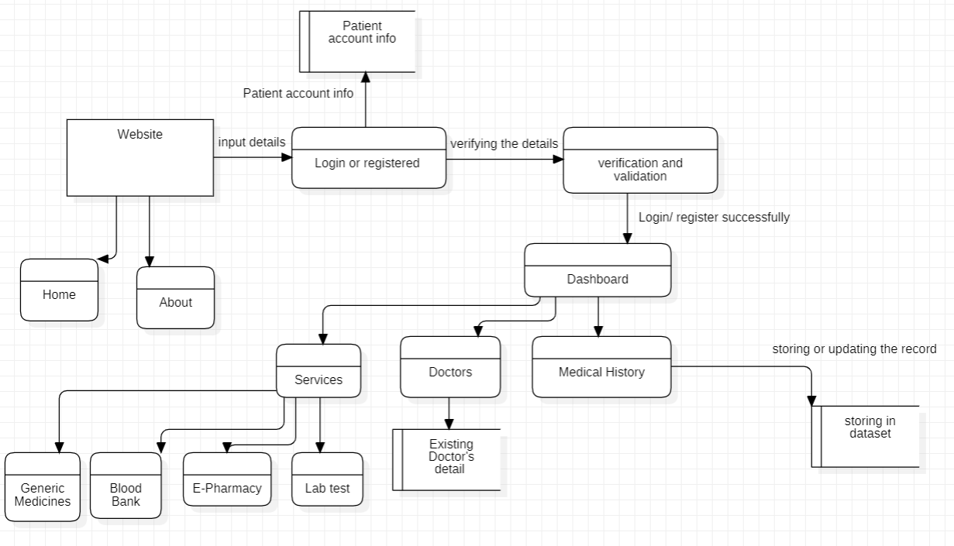**Figure: Showing the patient’s data flow diagram level 2**

**State Chart Diagram**

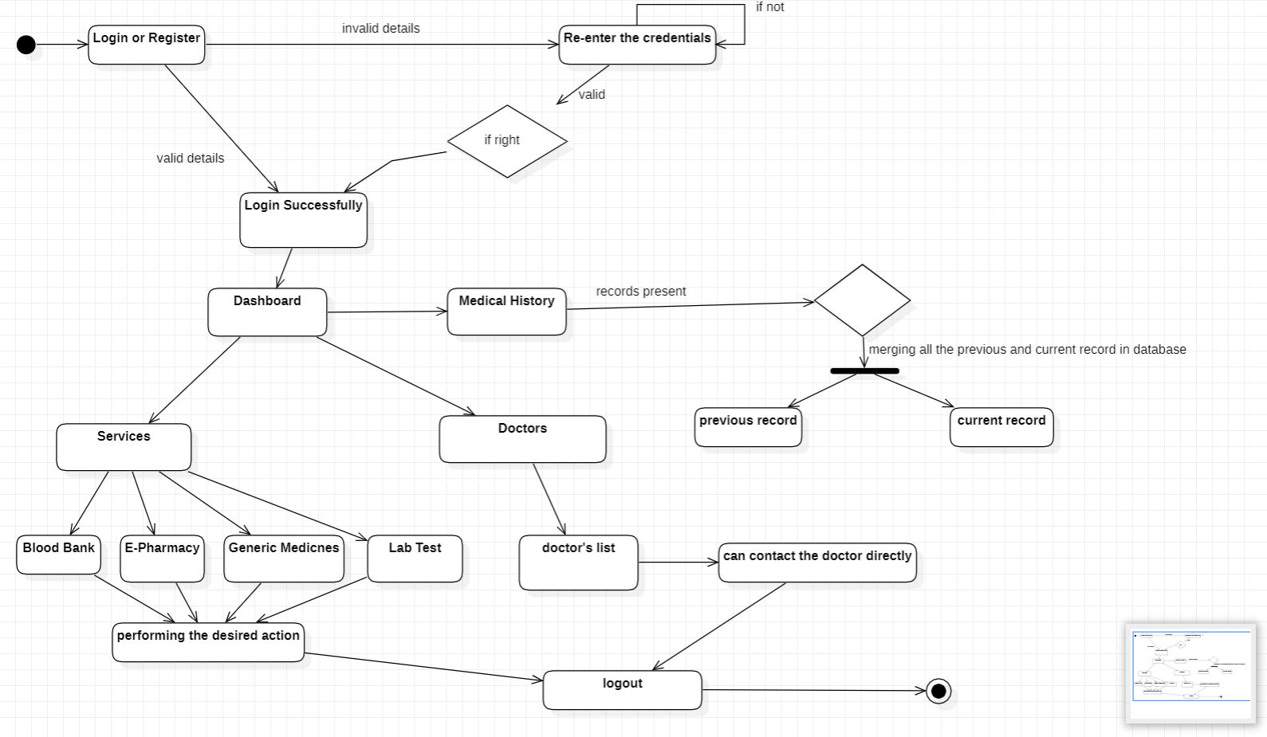

**Figure : Showing the patient login state chart diagram**

**CLAIMS**

* **Improved accuracy –**

Smart Health can provide more accurate results of services like generic medicines, E-Pharmacy than traditional risk assessment methods. This is because large amount of patient is going to visit our website which are already confused in buying the medicines among which website, so that they will be satisfied in terms of cost.

* **Early Services –**

Smart Health can help to provide the free services like Blood Bank, Lab Test, E-Pharmacy without any login or registration to the website. This improves the users accessing rate to our Smart Healthcare website.

* **Personalized Generic Medicines –**

Smart Health can provide personalized recommendations for buying the medicines from correct platform in terms of cost estimation. This can improve the individual risk factors which were affecting them like overall cost of medicines, their manufacturing dates and expiry dates.

* **Providing the correct treatment** **–**

Smart Health registered patients can get the better and correct treatment for their diseases. The prescriptions are provided by the doctor to the patient virtually. This is advantageous, as there is no loss of documents will be occurred.

* **Providing Virtual Storage –**

Smart Health is providing the storage for patient to store their medical history all together at one place. This will be advantageous, as it reduces the need of documents in hand. All the prescriptions are saved and secure from other non authorized users also.

**TECHNOLOGY USED**

* **Hardware –**

Even though this architecture is hardware- software integrated web architecture, we will not be designing any specific hardware interfaces to run the system. Our system is a web-based system, so we will be launching it in several computers online. Smart care projects may integrate with EHR systems to provide healthcare professionals with access to patient data. These systems can be connected to the web-based platform via APIs.

* **Software –**

The Smart Care WebApp will depend on several open-source software components, including Html, CSS, JavaScript, API’s ,Spring MVC, Spring Security, Spring JDBC and Spring Boot. These components will be integrated into the web application to provide the necessary functionality and user interface. It is important to note that the operating environment described above is subject to change based on the needs of the project and the evolving requirements of the web application. It is recommended that the development team regularly review and update the operating environment to ensure that the software remains compatible with the latest technologies and platforms.

**ABSTRACT**

The Smart Healthcare website which aims to solve many problem of patients and doctors i.e it provides the facility of saving the medical reports online. Sometimes when patients changes their doctors, then some of patients lost their prescriptions and are unable to tell doctors about their previous health issues so they can save all of their reports and documents on the platform for their better cure. The platform is also helpful for doctor as doctor can save all their patients history in efficient manner. Doctors can also refer prescriptions of other doctor for betterment.

**END USERS**

* Patients –

Can save their documents

Check for doctor according to their needs

Compare medicine price

* Doctors-

Can save their patients history

Take Help prescription of other doctors

**ADVANTAGES**

* Access **-**the access of our website is not restricted to registered users only. Someone who is not registered can also visit the website
* User Registration and login **-** A user, must be able to register their credentials. one should provide their basic information eg. Name, address, email, phone number to create the profile.
* Electronic Health Records **-** This is a feature to digitalize the patient’s medical records , It’ll contain the patient's medical history, diagnoses, medications, treatment plans, immunization dates, and laboratory test results.
* Telemedicine **-** This feature allows the patient to buy the medicine online form the registered government websites. This feature helps the user to buy the medicines in low prices as compared to all other private medicines shop.
* Online Blood bank **-** This features allows the patient to see the blood donors availability according to the blood group. This is also the registered and approved government website which will provide the filtered data so that the relevant information of the acceptor and donor is displayed.
* Online Path Labs **-** This feature allows the patient to access the government official website for appointing the test in pathology labs. This is also the home service provided by the government to the patients.
* Doctor’ Dashboard **-** Doctor’s Dashboard allows doctor’s to access the appointed patient’s only. Doctor can see their past records also such as medical records, test results and past prescriptions (from other doctor). As doctor has to provide the electronic prescriptions, which reduces the risk of errors and making it easier for patients to refill their prescriptions. It also consists of many other options such as other doctors where the list of registered doctors are made visible.

**SUMMARY**

The Smart Healthcare website which aims to solve many problem of patients and doctors that it provides the facility of saving the medical reports online. Sometimes when patients changes their doctors, then some of patients lost their prescriptions and are unable to tell doctors about their previous health issues so they can save all of their reports and documents on the platform for their better cure and this help a lot to patients as well as doctors. The platform is also helpful for doctor as they can save all their patients history in efficient manner. Doctors can also refer prescriptions of other doctor for betterment , both patients and doctor can also compare price of medicine so that they can save their money.